

***Hands-on Exercise 4.3 [15-points]: Factory Method Pattern (:20 min):***

### *Instructions:*

* According to some research, industry values documentation, and excellent written and oral communication skills. The purpose of this part of the class is to encourage you to gain these skills.
* Backup your work to your USB drive for this material may come out as part of your examination.
* Make a copy of this entire document and add your work into it.
* Submit to Blackboard at the same link where you got this document.
* Points will be deducted if submitted on the wrong place, or if these instructions are not followed.

1.❑ Let’s practice: Implement the Factory Method Pattern below and get the code to run.

***The Project***

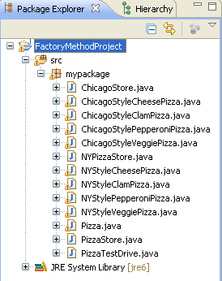

***The Code***

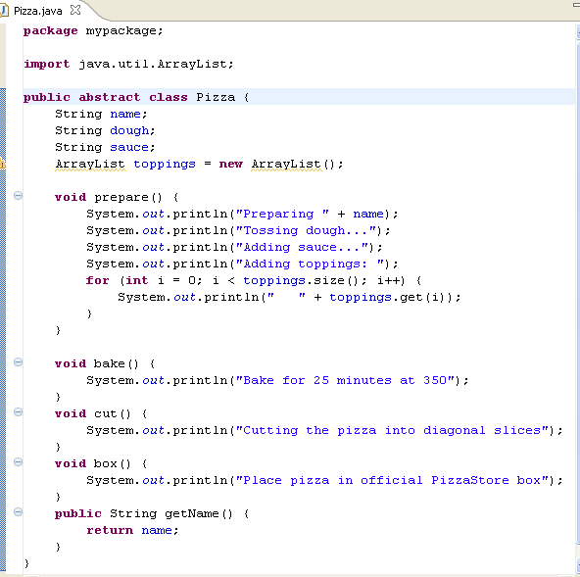

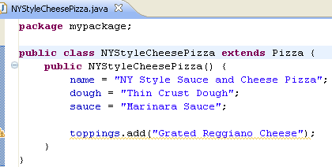

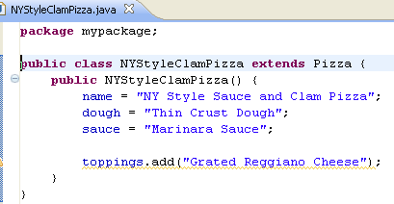

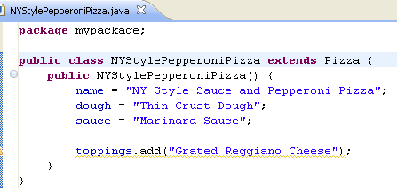

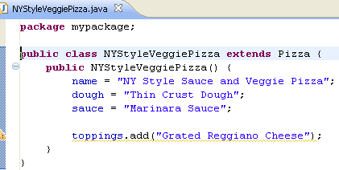

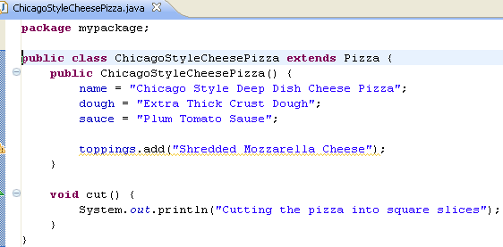

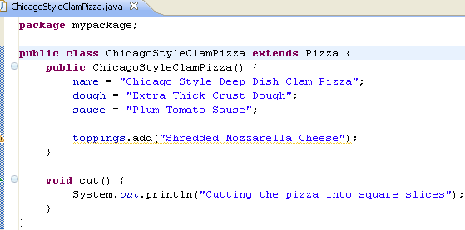

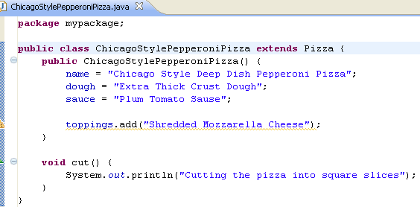

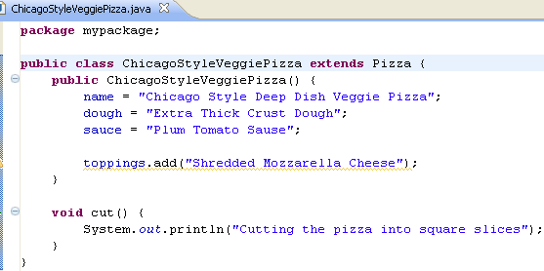

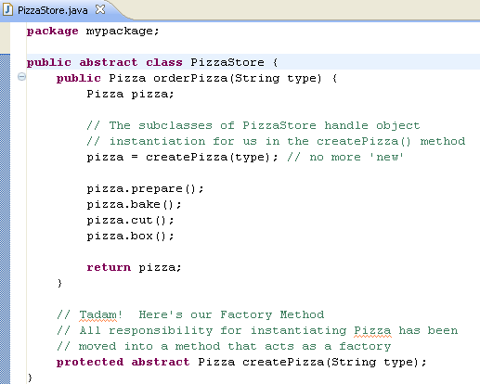

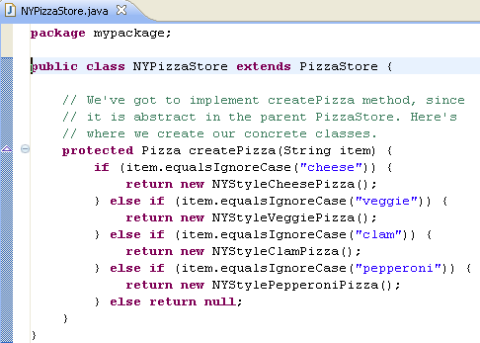

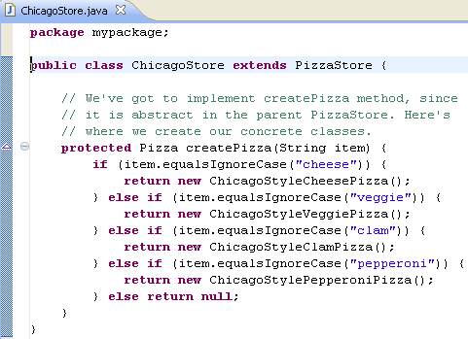

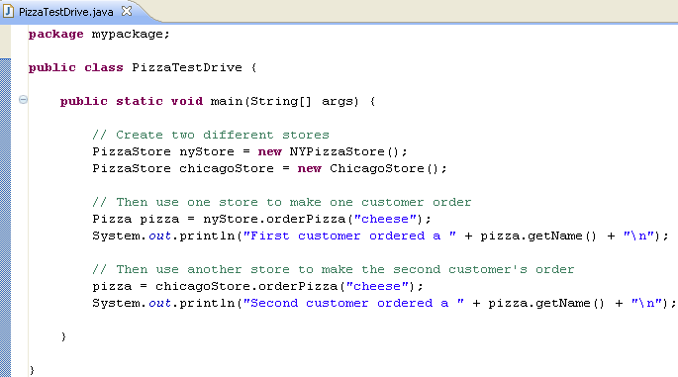

***The Output***

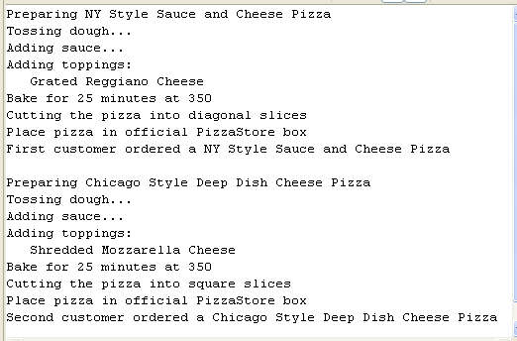

Paste your code here:

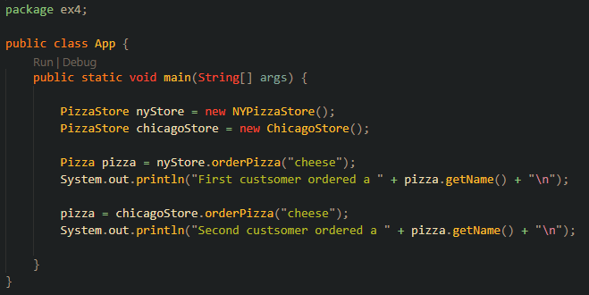

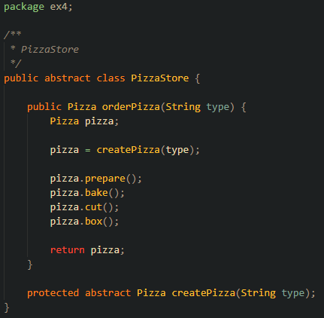

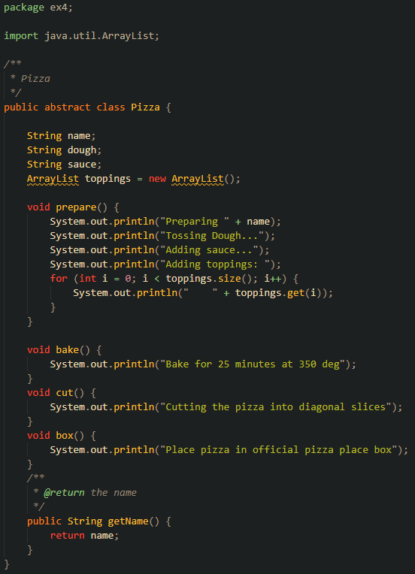

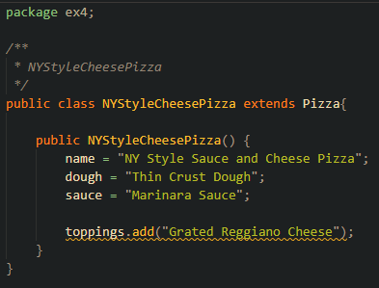

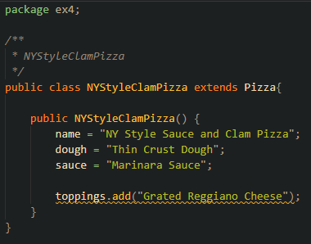

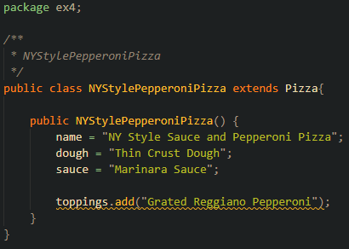

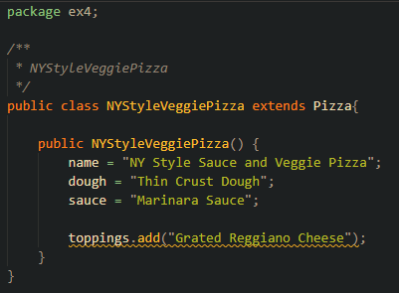

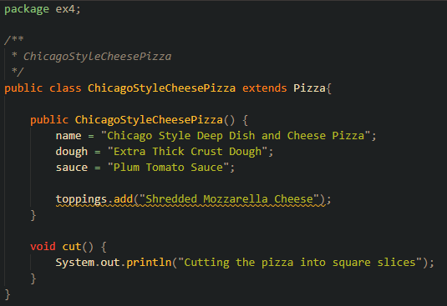

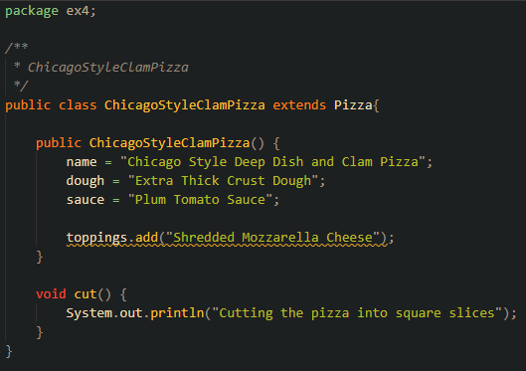

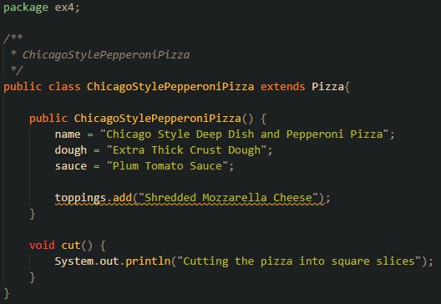

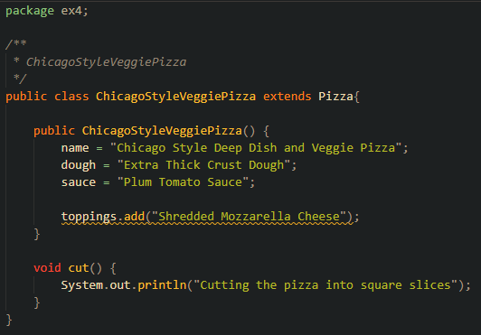

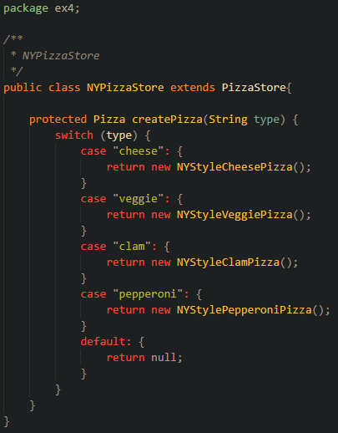

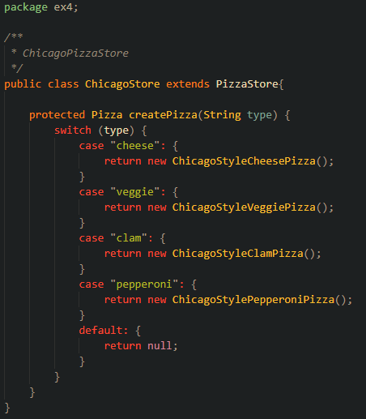

Paste your output here:

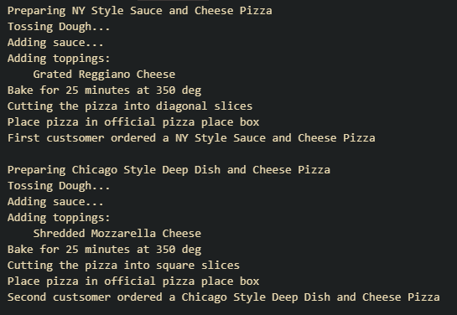

2.❑ Open CaliforniaPizzaStore offering three kinds of pizza.

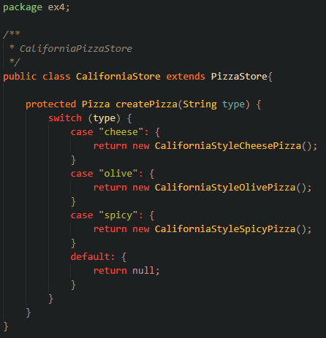

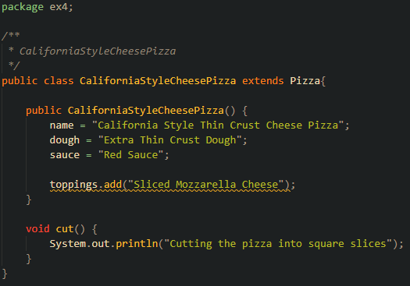

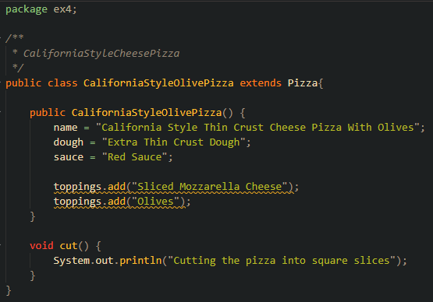

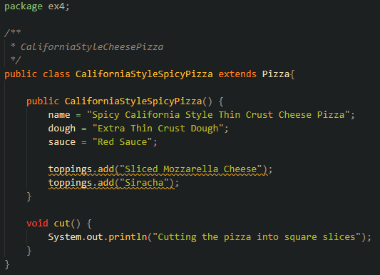

3.❑ Draw the equivalent UML class diagram of the code solution above?

Paste your code here:

Paste your output here:

4.❑ Write your topmost question regarding this topic.

5.❑ **Critical Thinking:** If you are asked to make a test question based on this topic, what would be the question and what is your answer?

[](http://images.google.com/imgres?imgurl=www.skyscript.co.uk/im/trophy.jpg&imgrefurl=http://www.skyscript.co.uk/im/&h=214&w=180&sz=6&tbnid=ECCiP8U-7NsJ:&tbnh=99&tbnw=84&prev=/images?q=trophy&svnum=10&hl=en&lr=&ie=UTF-8&oe=UTF-8&sa=G)Congratulations! You’ve just learned the Factory Method Pattern.

**Submission Procedure**

1. Write your **name** here: __________________________
2. Date: __________________________
3. **Backup** your work to your USB drive, this material may come out as part of your exam.
4. **Submit** to Blackboard at the link where you got it.

**Note:**

* 2-points deduction if you submit it in the wrong place.
* 2-points deduction if you did not follow these instructions.
* Make sure you submit it at the correct location where you got it.

|  |  |  |  |  |
| --- | --- | --- | --- | --- |
| GRADING RUBRIC | | | | |
| Grading Criteria | 3  **Exceeds**  *Excellent*  Epic Wow | 2  **Meets**  *Satisfactory*  O.K. | 1  **Partially Meets**  *Below Expectations*  Not Yet | 0  **Does Not Meet**  *Unacceptable*  Fail |
| **Coding** | +5- Code is excellent, comments are added, and different techniques were used. | +3-Code is O.K., and program works. | +2-Code works, but still needs improvement. | Unfortunately, no coding. |
| **Completeness** | +5-Completed all the required work and added more examples. | +3-Completed all the work required. | +2-Partially completed the work required. | Unfortunately, did not complete the work required. |
| **Output and diagram** | +5-Outputs are correct, and provided additional output cases. | +3-Output meets requirements and is readable. | +2-There is output, but not readable, and/or needs improvement. | Unfortunately, no output, or diagram was generated. |
| **Late** | Excellent, you submitted it before the deadline. | -5, unfortunately for submitting after the deadline. | -10, unfortunately for submitting several weeks after the deadline. | -15, unfortunately, for submitting very late. |